

.………………………………
place, date
…………………………………………………..……..
Name and Surname of the author
…………………………………………………..……..
affiliation (College/ University, department)
…………………………………………………..……..
adres
…………………………………………………..……..
e-mail, phone number

Declaration of originality, financial source and paper availability

I hereby declare that the article submitted for publication in the scientific journal STUDIA MIEJSKIE, entitled::
…………………………………………………………………………………………………………………………….……………………………………………………………………………………………………………………………………………………………….…………………………………

- is a scientific publication providing:*
* mark as appropriate
- the current state of knowledge in the field of expertise discussed (a survey publication),
- results of the author’s own research,
- a new interpretation of research results developed by other authors referred to in the publication,
- information about the results of research conducted by persons referred to the article
- case study

- is an original work and has neither been published in any other peer-reviewed journal nor is under consideration for publication by any other journal

- does not breach any copyrights or legal and material interest of third parties under the law of 4th February 1994 on copyrights and associated rights (Official Journal of Laws no. 24, item 83 as amended)

4. was drawn up by me in ………..…%, and moreover persons or institutions were involved in making the article *:
* please point items which took a part in making article, and to determine their scope of work
- …………………………………………………………………………………………………….................………...………………
- …………………………………………………………………………………………………………………….................…………

5. does not a subject of ghostwriting and guest authorship or other similar according to recommendation of Ministry of Science and High Education concerning security against ghostwriting and guest authorship

6. during the process of preparation or submit for print was funded by*:
*please point an percentage every kind of used sources
a) author private source: ………………………………………….……………………………………………..…………..………
b) university, college/work place: ………………………………………………………………...……...……………………….
c) subsity/research project (name, number) ………………………………………….…………………………..…………...
…………………………………………………………………………………………………………………………........….……............
d) others……..…………………………………………………………..…...…………………………………………….…….........….

I give my consent for the publication of the above mentioned article on the website of the scientific journal www.studiamiejskie.uni.opole.pl

……………………..………………… …………………………….……….
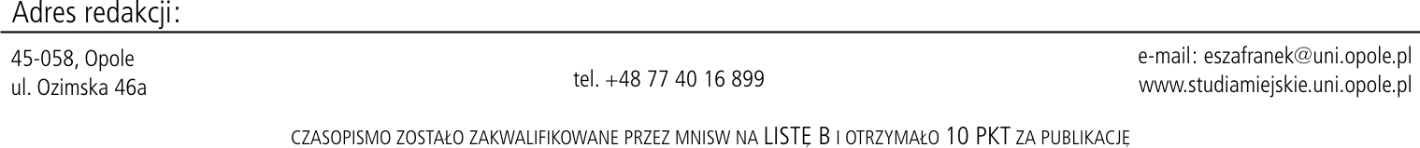
date author signature

