ARTICLE REVIEW

Article title: …………………………………………………………………………………………………………………………………....…..………
………………………………………………………………………………………………………………………………..………………

PART I. Assessment of the article (please indicate one answer for each category)
 | Unsatisfa ctory* | Satisfa ctory | Good | Very good | Excellent
Relevance of the topic
To what extent is the topic relevant from the scientific point of view?
Novelty
To what extent does the article contain new ideas?
Originality
To what extent is the artical original, i.e., are the ideas presented important in comparison to the present state of the art?
Application of results
To what extent can the result of the paper be applied in practice or contribute to the development of theory?
Methodological aspects
To what extent are the proper research methods used and applied? Are research data properly presented and analysed?
Clarity of arguments
To what extent are the arguments presented in a clear, transparent and logical way?
Logic of structure
To what extent is the structure of the article clear, coherent and consequent?
Illustrations and tables
To what extent are the illustrations used (tables, figures, diagrams, etc.) properly designed and presented?
Literature used
To what extent is the literaturę properly selected? Are there important papers the author(s) have not mentioned?
Formal and language issues
To what extent is the article written using proper, understandable and scientific language?
Scientific level
To what extent is the article scientific?
* - - please explain in part III

PART II. Conclusion – please indicate either yes or no.
 | tak | nie
The article can be published without changes
The article can be published after minor changed
After serious improvement, the article should be sent for acceptation by the reviewer
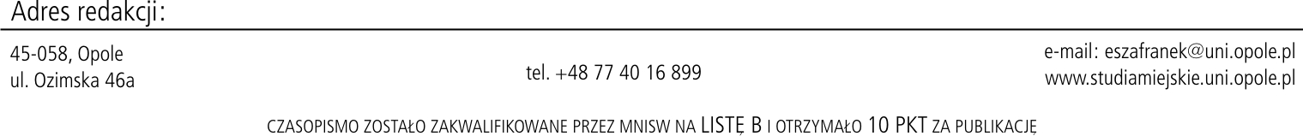

PART III. Explanation when one of the categories in Part I was assessed as unsatisfactory.
Comments:

Changes to be made before publishing the article:
Necessary changes:
Optional changes:
The information below will be available only for the Editorial Office, according to the “double blind review” procedure
First and last name of the Reviewer  …………………………………………………………………… | Signature

